Order Of Lenten Service

Opening Hymn: TLH 145

Reading: Lent III

The History of the Passion of our Lord

Sermon Hymn: TLH 144

Sermon Text: Daniel 3:19-25

Into The Fiery Furnace

Prayer

Holy Communion

The Lord's Prayer

The Blessing

Closing Hymn: TLH 146

* * * * * * * * * * * * *

Bible Study: Lambs: Turkey Vulture
Sheep: Romans 9:14-24

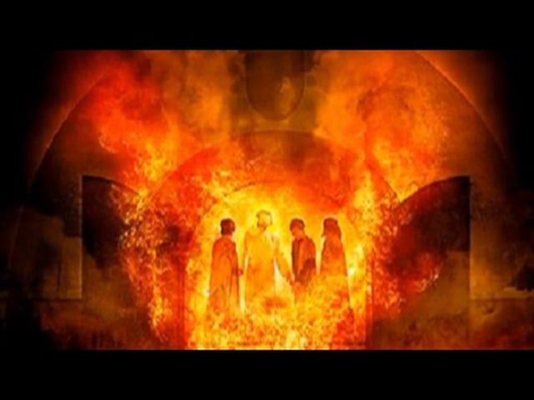

The Fiery Furnace

Water
Of
Life

25 February 2018

W A T E R O F L I F E

Independent Christian Church—Conservative Lutheran Doctrine

Worship Service: 9:30 a.m. Bible Study: 10:45 a.m.

Larry Cooper, Pastor E-Mail address:
111 N. Ridge Road lcooper@wateroflife.cc
Coon Valley, WI 54623 Web Site:
Phone: (608) 452-2105 www.wateroflife.cc

* * * * * * * * * * * * * * * * * * * * * * * * * * *

Sermon Text: Daniel 3:19-25

Into The Fiery Furnace

* * * * * * * * * * * * * * * * * * * * * * * * * * *

Daniel 3:19 Then was Nebuchadnezzar full of fury, and the form of his visage was changed against Shadrach, Meshach, and Abednego: therefore he spake, and commanded that they should heat the furnace one seven times more than it was wont to be heated.
:20 And he commanded the most mighty men that were in his army to bind Shadrach, Meshach, and Abednego, and to cast them into the burning fiery furnace.
:21 Then these men were bound in their coats, their hosen, and their hats, and their other garments, and were cast into the midst of the burning fiery furnace.

:22 Therefore because the king's commandment was urgent, and the furnace exceeding hot, the flame of the fire slew those men that took up Shadrach, Meshach, and Abednego.
:23 And these three men, Shadrach, Meshach, and Abednego, fell down bound into the midst of the burning fiery furnace.
:24 Then Nebuchadnezzar the king was astonied, and rose up in haste, and spake, and said unto his counsellors, Did not we cast three men bound into the midst of the fire? They answered and said unto the king, True, O king.
:25 He answered and said, Lo, I see four men loose, walking in the midst of the fire, and they have no hurt; and the form of the fourth is like the Son of God.

* * * * * * *
Related Readings:

1 Peter 4:12 Beloved, think it not strange concerning the fiery trial which is to try you, as though some strange thing happened unto you:
:13 But rejoice, inasmuch as ye are partakers of Christ's sufferings; that, when his glory shall be revealed, ye may be glad also with exceeding joy.

Isaiah 43:1-3

1 But now thus saith the LORD that created thee, O Jacob, and he that formed thee, O Israel, Fear not: for I have redeemed thee, I have called thee by thy name; thou art mine.
2 When thou passest through the waters, I will be with thee; and through the rivers, they shall not overflow thee: when thou walkest through the fire, thou shalt not be burned; neither shall the flame kindle upon thee.
3 For I am the LORD thy God, the Holy One of Israel, thy Saviour:

